Lambda Chi Alpha
  - Iota Sigma April 2013 Newsletter
Golf Outing
Thanks to everyone who came out to the golf outing. The weather was just a bit chilly, but it was great to meet all of you.
If you have any comments or ideas to help with planning of next year’s outing. Feel free to email me.
Hope to see you all at future events.

In ZAX,
Garrett Rietveld
Iota-Sigma 1034
Garrett.Rietveld@valpo.edu

[Click here to add a caption]

St. Baldrick’s Results
Over the past couple months we have been raising money to support St. Baldrick’s, an organization that helps fund childhood cancer research. We raised $1,277 which earned us 4th place overall and 1st place in Greek Life. We also had 10 brothers including myself, who shaved their heads to support the cause and raise awareness. Thanks to anyone who helped us exceed our goal.
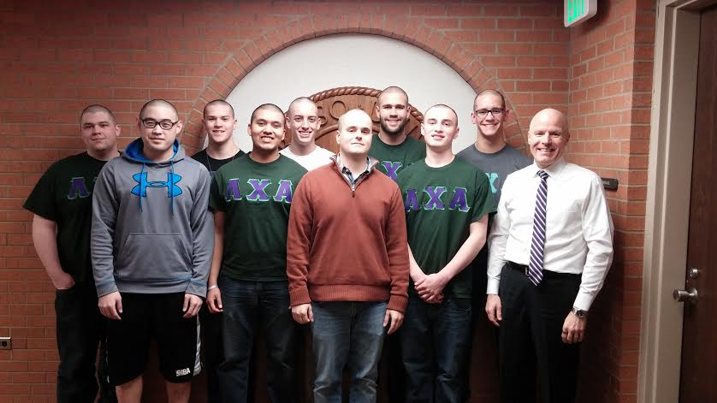

Master Steward Visit
This past month, we had invited Master Steward Jon Williamson to come and discuss recruitment ideas and methods. During his conversation, he gave us many new ideas, as well as left us with two phrases to remember. The first being, “Success is a choice,” and the second being “Represent what we Represent.” These two phrases not only have meaning for recruiting our new members, but can help in any aspect of life.

Congrats Brother Josh Bieck
This month, UPC held their annual Student Affairs awards, and this year, Josh Bieck was awarded the 2014 Outstanding Leadership and Service Award.

